EXPERIMENT

AIM

To Study the duration required for Seed Germination under normal Condition

MATERIALS REQUIRED

* Paper towels
* Paper Cup
* Seeds of Brinjal
* Green Gram
* Chilly seeds
* Lady’s Finger
* Beans
* Water

PROCEDURE

* Take a Handful of Seeds
* Soak the seeds overnight in water. This will sort of wake up the seeds and get them ready to germinate. During this process it is beneficial to rinse the seeds in water a couple of times to wash the seeds and let them get some oxygen.
* Dampen a paper towel and fold it into the paper cup. Place the seeds won the damp surface.
* After distributing the seeds on the growing medium surface, apply some water occasionally using a spray bottle, just to keep seed moist during the germination process.
* To facilitate the germination process and keep good moisture level during the germination it is recommended to keep the seeds in a dark environment for a few days
* For some species, it is recommended to put some weight on the seeds during germination process to keep the seed in contact with the soil and maintaining the weight on the top of the sheets during germination process also facilitates the detachment of the seeds from the cotyledons
* after the germination process is complete and seedlings reach a certain height, expose the sprouts to sunlight as they start growing, if light is limited shoots will lean towards the light
* Water should be provided only if necessary, avoiding excess of moisture and allowing to prevent the development of the mold

**ACKNOWLEDGEMENT**

First of all I would like to thank our Biology teacher Mrs. Bindu O for her continuous support for the project, from initial advices and contacts. In the earlier stage of conceptual inception and through ongoing advice and encouragement to this day.

I would like to express my gratitude to our principal Mr. Sasi K for providing all the required facilities for the project.

Special thanks of mine goes to my group mates who helped me in completing the project and for supporting me throughout.

I would also extend my gratitude and thanks to our lab assistant Mrs. Prema who has helped me in successful completion of the project.

Brinjal or Egg Plant (Solanum melongena)

|  |  |  |  |  |
| --- | --- | --- | --- | --- |
| Day 5 | Day 6 | Day 7 | Day 8 |  |
| The seeds are open up a Germination is distinct | The Germinated Seeds shows a green leaf like structure | There is a Slight Growth in Leaf in normal condition | The Two leaf are distinct |  |

|  |  |  |  |  |
| --- | --- | --- | --- | --- |
| Day 1 | Day 2 | Day 3 | Day 4 |  |
| The seeds put for Germination | Seeds are soaked in water | Seed are taken out of the water and are placed in a paper cup having wet tissue at its base | The seeds open up shows a slight Germination |  |

*Brinjal is also called Eggplant is an important solanaceous crop of subtropics and tropics. Once the seeds germinate, seedlings grow for 6 to 10 weeks before they're ready to transplant. Seedlings are strong enough to transplant when they develop from 2 to 4 leaves.*

***It takes about 8 days to show the two to three leafed stages***

OBSERVATION

Lady’s Finger (Abelmoschus esculentus)

*Lady’s Finger is also known as okra and is an important vegetable crop in India.It is grown in both tropical and sub-tropical regions and also in the warmer parts of the moderate regions.*

|  |  |  |  |
| --- | --- | --- | --- |
| Day 1 | Day 2 | Day 3 | Day 4 |
| The seeds put for Germination | Small Germination is Identified on the seeds | Seed has Germinated and has a slight greenish-white, Plumule like Structure | The green coating of the seed is torn and whitish-green color of the seed is observed |

|  |  |  |  |
| --- | --- | --- | --- |
| Day 5 | Day 6 | Day 7 | Day 8 |
| The Germinated seeds are seen to be Growing In the Vertical direction | The vertical plants seed have very small buds and increase in height | Two leaves have come out of the plant .Thus we have a Two leafed stage | Several seed have emerged |

**

SURYAKIRAN ANIL

ROLL NO: 3

XII-A

*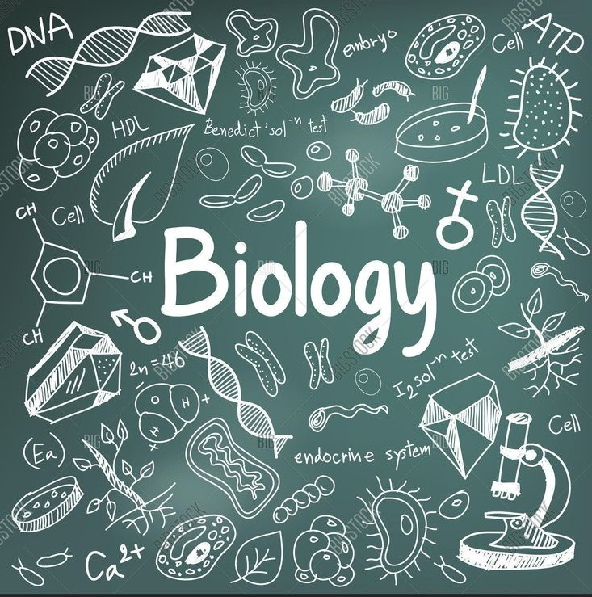as*

CHAITRA MAHENDRAN

ROLL NO:- 15

XII-A

BIBLIOGRAPHY

[**WWW.GOOGLE.COM**](http://WWW.GOOGLE.COM)

[**WWW.YOUTUBE.COM**](http://WWW.YOUTUBE.COM)

[**WWW.BYJUS.COM**](http://WWW.BYJUS.COM)

**NCERT BIOLOGY CLASS 12**

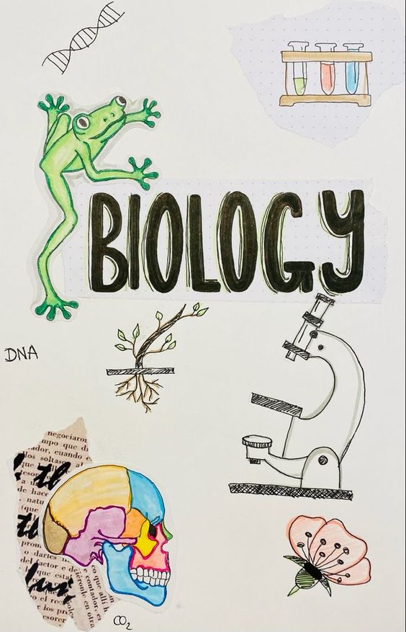**A**

SURYAKIRAN ANIL

XXII-A

ROLLL NO:-3

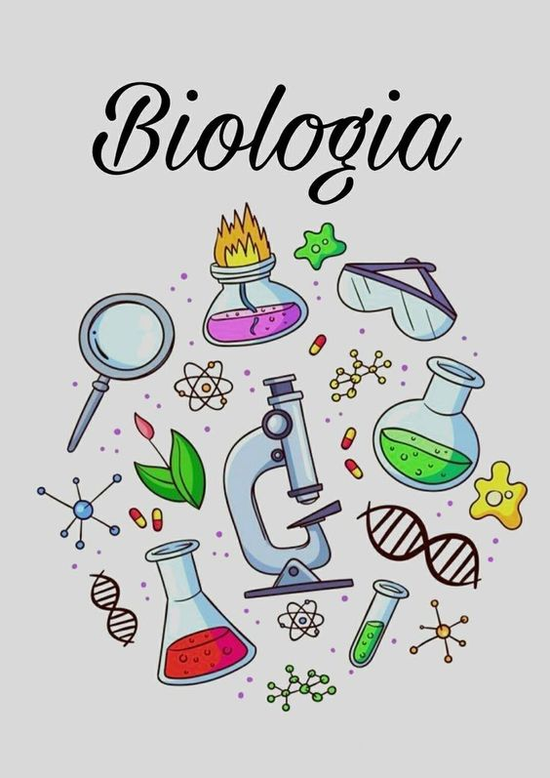

**.**

ANJUM RAHMAN

XII-A

ROLL NO:-10



CHAITRA MAHENDRAN

ROLL NO:- 15

XII-A

OBSERVATION

CHILLY

**Chilly seeds generally grow faster in the sun than in the shades. They require a slightly higher temperature as well. Physical growth starts observing at day six where sprouting are seen at the pointy ends of the seeds. They have an average growth rate of 0.25cm per day as average**

|  |  |  |  |
| --- | --- | --- | --- |
| Day 1 | Day 2 | Day 3 | Day 4 |
| The seeds put for Germination | Small Germination is Identified on the seeds | Seed has Germinated and has a slight greenish-white, Plumule like Structure | The green coating of the seed is torn and whitish-green color of the seed is observed |
| Day 5 | Day 6 | Day 7 | Day 8 |
| The Germinated seeds are seen to be Growing In the Vertical direction | The vertical plants seed have very small buds and increase in height | Two leaves have come out of the plant .Thus we have a Two leafed stage | Several seed have emerged |

BEANS

*Plants need water to grow from a seed. The water is absorbed by the seed coating and that swells allowing the embryonic seed to emerge. The seed embryo has 2 points that develop and a large bean seed is ideal for showing these easily to kids.*

*First, the root tip grows and by geotropism (the process where the root grows down and the shoot grows up) it grows downwards. This root then divides at multiple points to allow more and more root development to let the plant take up the dissolved nutrients into the stem and to the leaves, flowers and fruit as needed.*

|  |  |  |  |  |  |  |
| --- | --- | --- | --- | --- | --- | --- |
| **Day 1** | **Day 2** | **Day 3** | **Day 4** | **Day 5** | **Day 6** | **Day 7** |
| **Seeds started swelling up** | **Sprout rise can be Observed** | **Sprout about 1 cm** | **Sprout starts to move upward direction** | **Small leaf like structure is seen** | **Leaf Started to expand** | **Small leaves are formed** |